AIESEC Conferences

What is AIESEC?
The world’s largest student-run organisation focused on developing globally-minded leaders to positively impact society through a continuously growing global network.
Our conferences are a premier platform for organisations to connect with globally diverse talent.
AIESEC International
- 107 Countries and Territories
- 1,700+ Universities
- 35,000+ Members
- 800,000+ Alumni
- 4,000 Partners and Sponsors
- 470 Annual Conferences

AIESEC United States
- 44 Universities
- 1,500+ Members
- 350+ Annual Exchanges
- 16 Annual Conferences

What is Summer National Conference?
A leadership conference hosting over 200 young leaders from the US and abroad for seven days of seminars in organizational skills and global awareness.
Attendees focus on developing strategies for leading their local committees in the year ahead, discuss new and innovative methods and opportunities for AIESEC, and cultivate valuable leadership and business skills.
This year’s conference will take place at the Metropolitan Hotel in Romulus, Michigan, from August 7 to August 13.

What’s in it for you?
An opportunity to contribute and interact with the next generation of leaders while building your global talent pipeline and brand image.

Name
AIESEC Entity
Phone Number
E-mail address
Website
AIESEC Partner’s Day

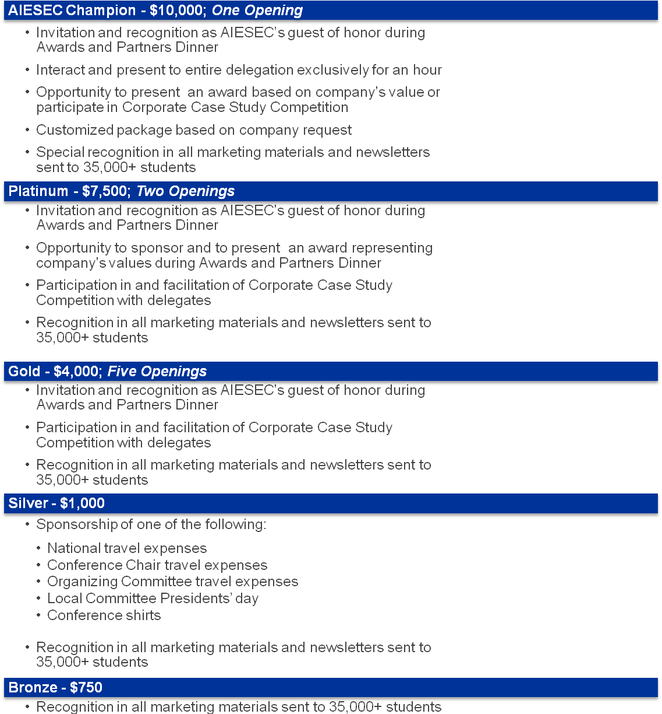
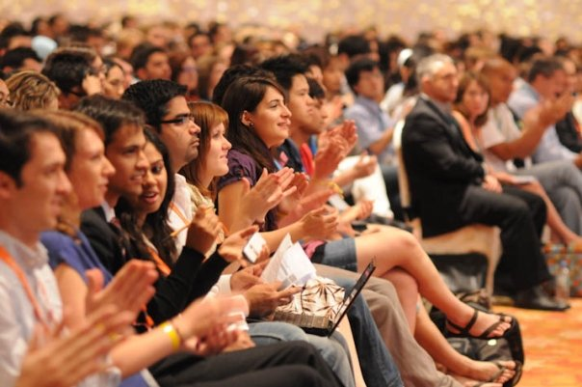
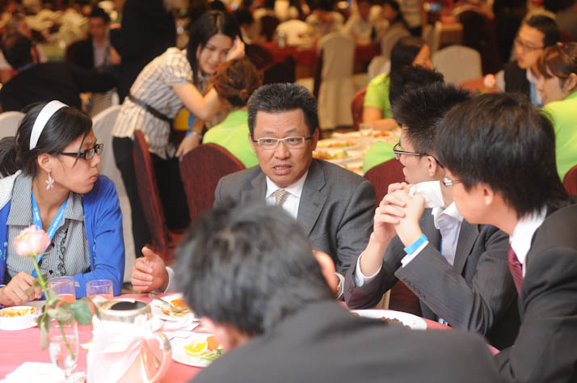
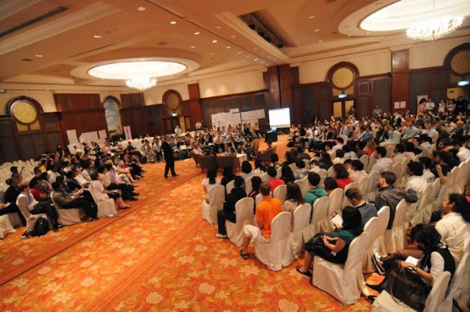
Sustainability Leadership
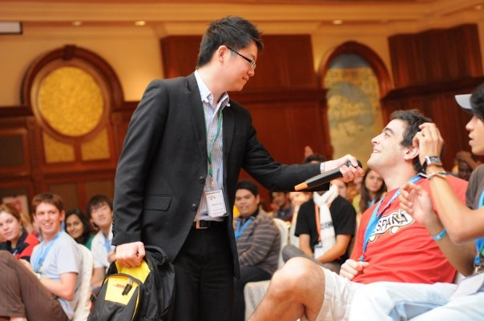
AIESEC Summer National Conference

Corporate Case Study Competition
Agenda

Friday, August 6th
President’s Pre-meeting

Saturday, August 7th
Opening Day

- Cases introduced

Sunday, August 8th
Alumni Day

Wednesday, August 12th
AIESEC Partner’s Day

- Corporate Case Study Competition

- Corporate Case Study winners chosen

- Formal Dinner & Awards Night

Thursday, August 13th
Closing Day
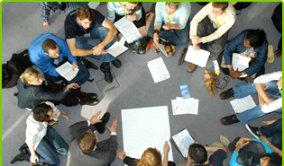
AIESEC’s Corporate Case Study Competition provides companies with an opportunity to take an active role in impacting the lives of the generation of leaders.

Case Studies
Agenda

Friday, August 6th
President’s Pre-meeting

Saturday, August 7th
Opening Day

- Cases introduced

Sunday, August 8th
Alumni Day

Wednesday, August 12th
AIESEC Partner’s Day

- Corporate Case Study Competition

- Corporate Case Study winners chosen

- Formal Dinner & Awards Night

Thursday, August 13th
Closing Day
Company participants and AIESEC United States will work together to develop a case study around the values of the company while reflecting the conference theme: Sustainability and Leadership in Globalization.

Case Competition
Agenda

Friday, August 6th
President’s Pre-meeting

Saturday, August 7th
Opening Day

- Cases introduced

Sunday, August 8th
Alumni Day

Wednesday, August 11th
AIESEC External’s Day

- Corporate Case Study Competition Discussion

- Corporate Case Study winners chosen

- Formal Awards Dinner

Friday, August 13th
Closing Day
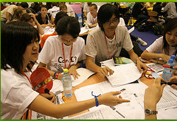
Delegates will be separated into case teams and assigned cases on Opening Day.
Each team will have an hour to work on their case each day until External’s Day.
On External’s Day, companies will facilitate discussions and presentations based upon their case. Each company will select a winner for their case study, all of who will be announced and recognized at the Awards Dinner that evening.
One overall case competition winner will be decided by the participating corporations and the AIESEC United States National Staff and will be awarded a prize at Awards Dinner.

